READER RESPONSE INSTRUCTIONS
FORMAT: APA
- Cover letter
- Abstract (250 words or a paragraph explaining what your paper is about).
- 1 page- single space (see requirements for page content below) FULL page.
- Reference page

Content 1 page single space
1st paragraph- intro APA format of reading (a summary): Here you will include your thesis statement highlighted or underlined. See templates for introducing the reading on Blackboard. I suggest you to print out the templates and make it a habit to use them on all your work. Try different ways to introduce your work and also to apply parenthetical citations using APA (framing quotations). Intro + quote + contribution
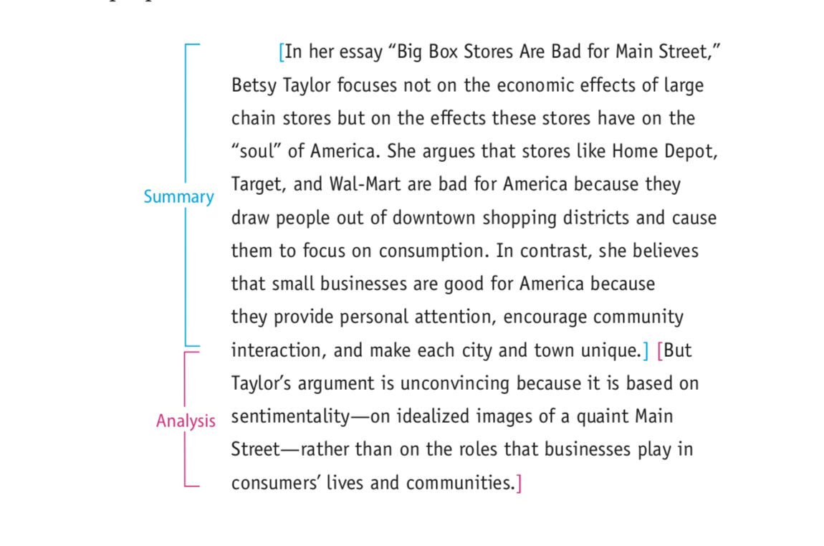
2nd paragraph- An analysis of the reading: here you can incorporate a quote APA framing quotations.
An analysis of a text allows you to examine the parts of a text to understand what it means and how it makes its meaning. Your goal is to offer your judgment of the text and to persuade readers to see it through your analytical perspective. Sample of analysis essay.
Drafting an analytical thesis statement
An effective thesis statement for analytical writing responds to a question about a text or tries to resolve a problem in the text. Remember that your thesis isn’t the same as the text’s thesis or main idea. Your thesis presents your judgment of the text’s argument.
If student writer Emilia Sanchez had started her analysis of “Big Box Stores Are Bad for Main Street” (pp. 72–73) with this thesis statement, she merely would have repeated the main idea of the article.

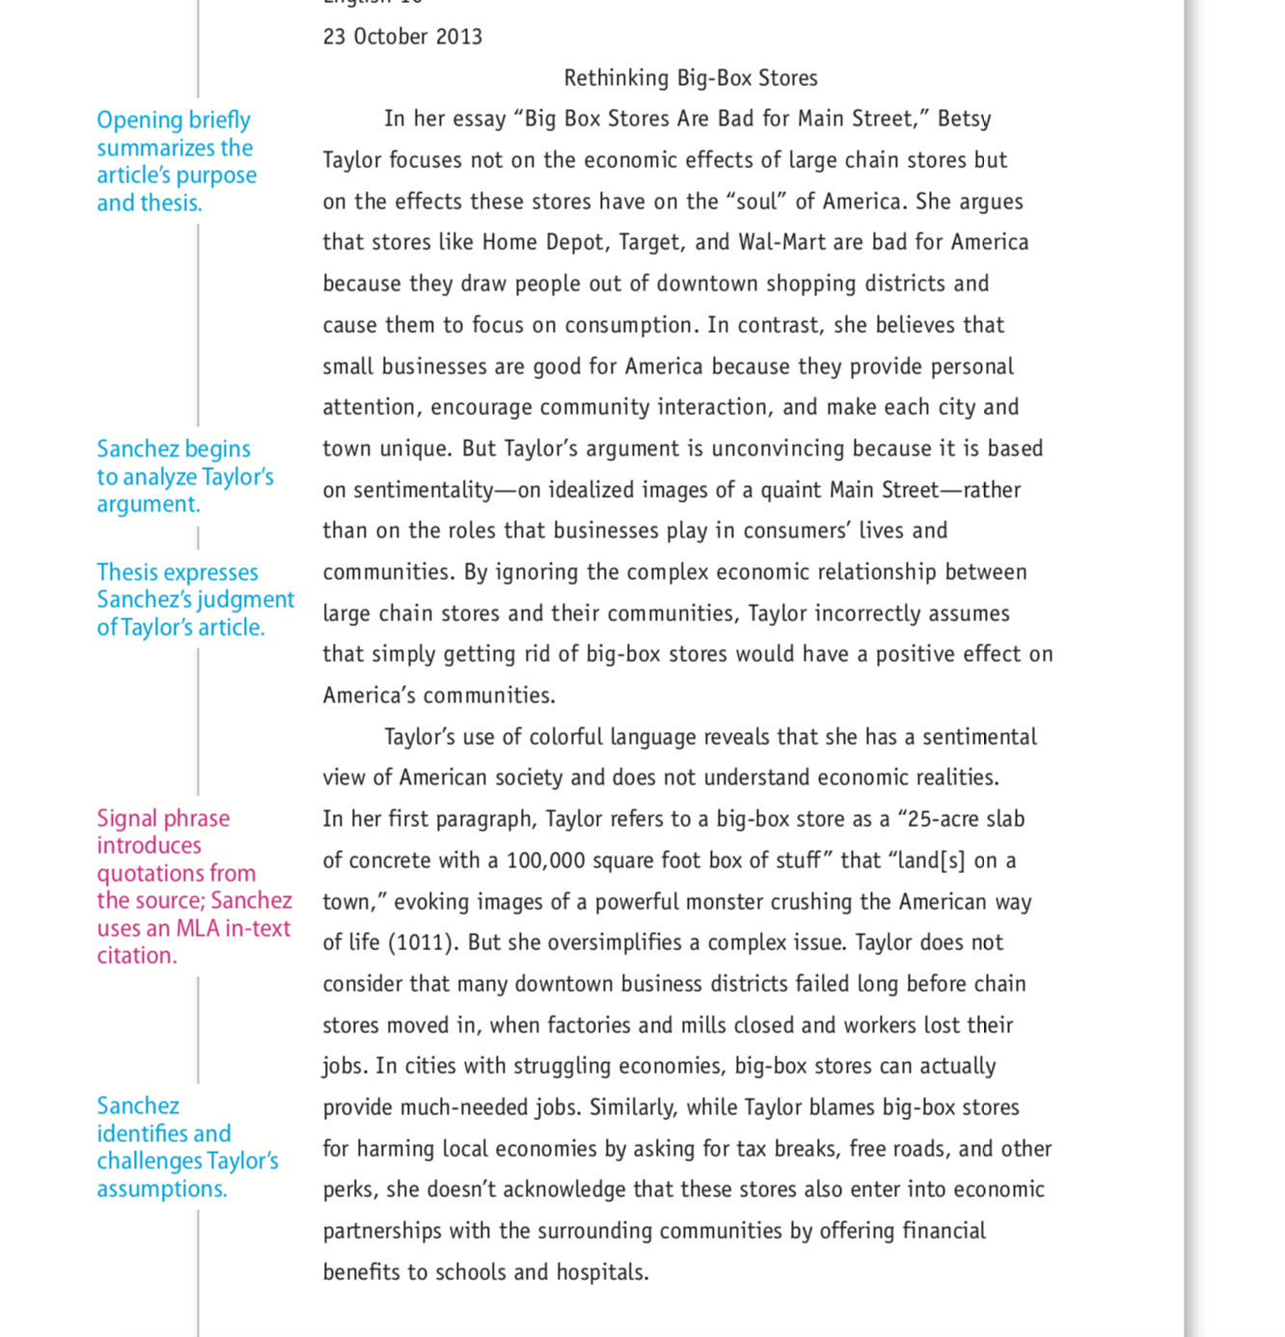
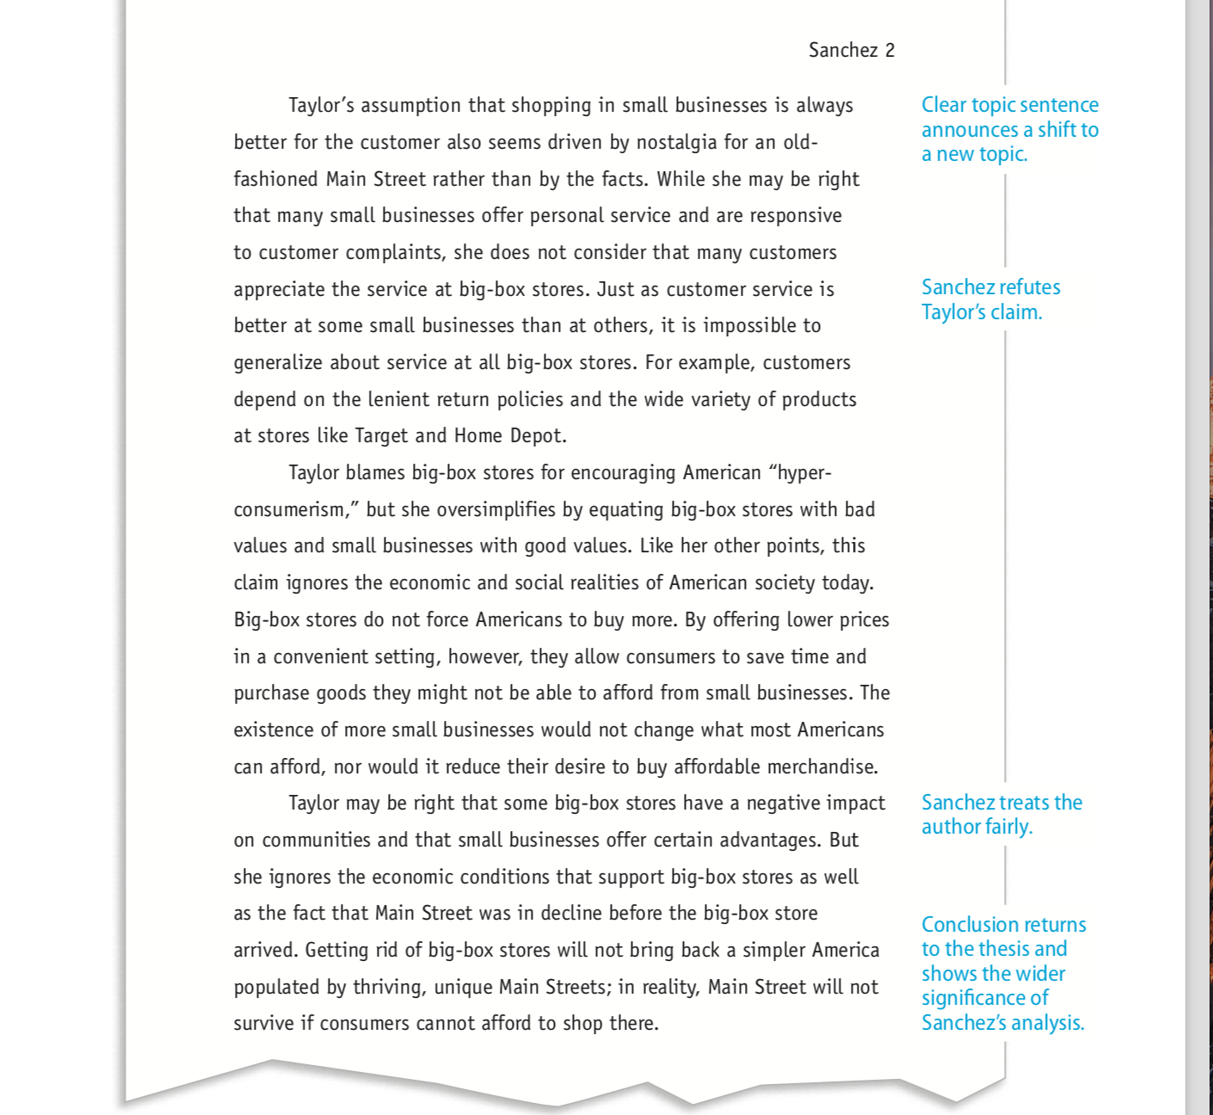
3rd paragraph- A synthesis of the reading (conclusion): here you can make a connection to other texts or use your preexisting knowledge in connection with the reading. This part should be clear and logical.

Placing sources in conversation
You can show readers how the ideas of one source relate to those of another by connecting and analyzing the ideas in your own voice. After all, you’ve done the research and thought the issues, so you should control the conversation. When you effectively synthesize sources, the thread of your argument should be easy to identify and to understand, with or without your sources.
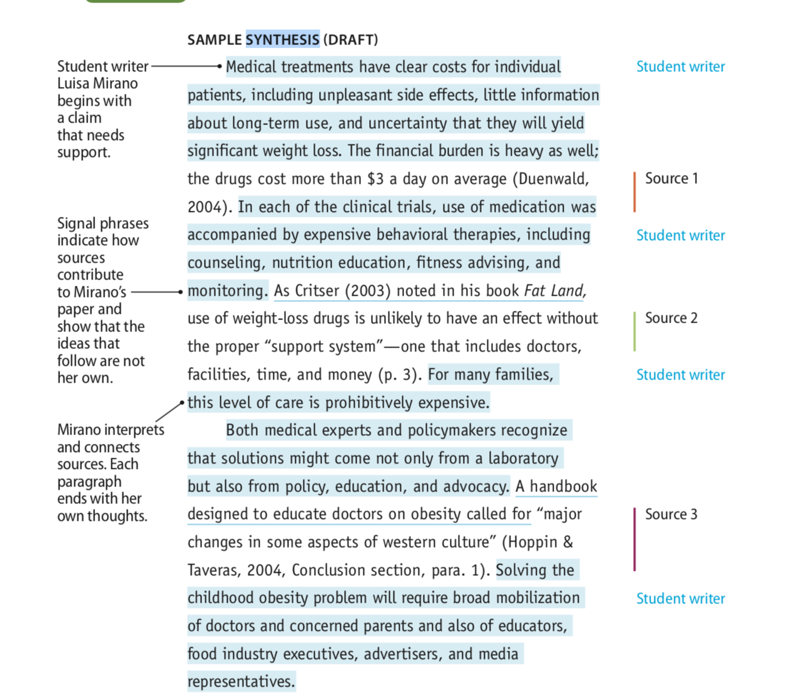

NOTE: this format of writing can change as you are exploring different ways of writing effectively.

Rubric for grading RR’s: I will grade every RR base on the use of analytical skills, synthesis skills, creativity, revision process and improvement on each RR.

A RR that effectively tries to address format, content, originality, revision, constant thesis revision, analysis, synthesis, summary, effectively incorporates quotes and uses templates effectively and creativity is a 20-25 points paper which is equivalent to A paper

A RR that addresses format (APA cover page, abstract, reference page) effectively and understands the language of summary (objective), analysis and synthesis and writes thoughts clearly is a 15-19 points paper.

A RR that does not show any improvement in terms of format (APA), no progress, no thesis development, no analysis, no synthesis, no paraphrasing, no quotes, no summary is a 4 or 3 points paper. It could be less points for not trying to revise your paper.

